Defect Report In JIRA
Evidences

URL: Swag lab - Summary - Service space - Jira
Sample bug created in Jira

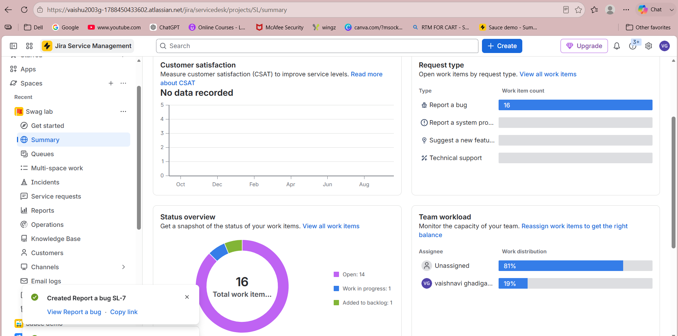

Link: Swag lab - Queues - All open - Service space - Jira
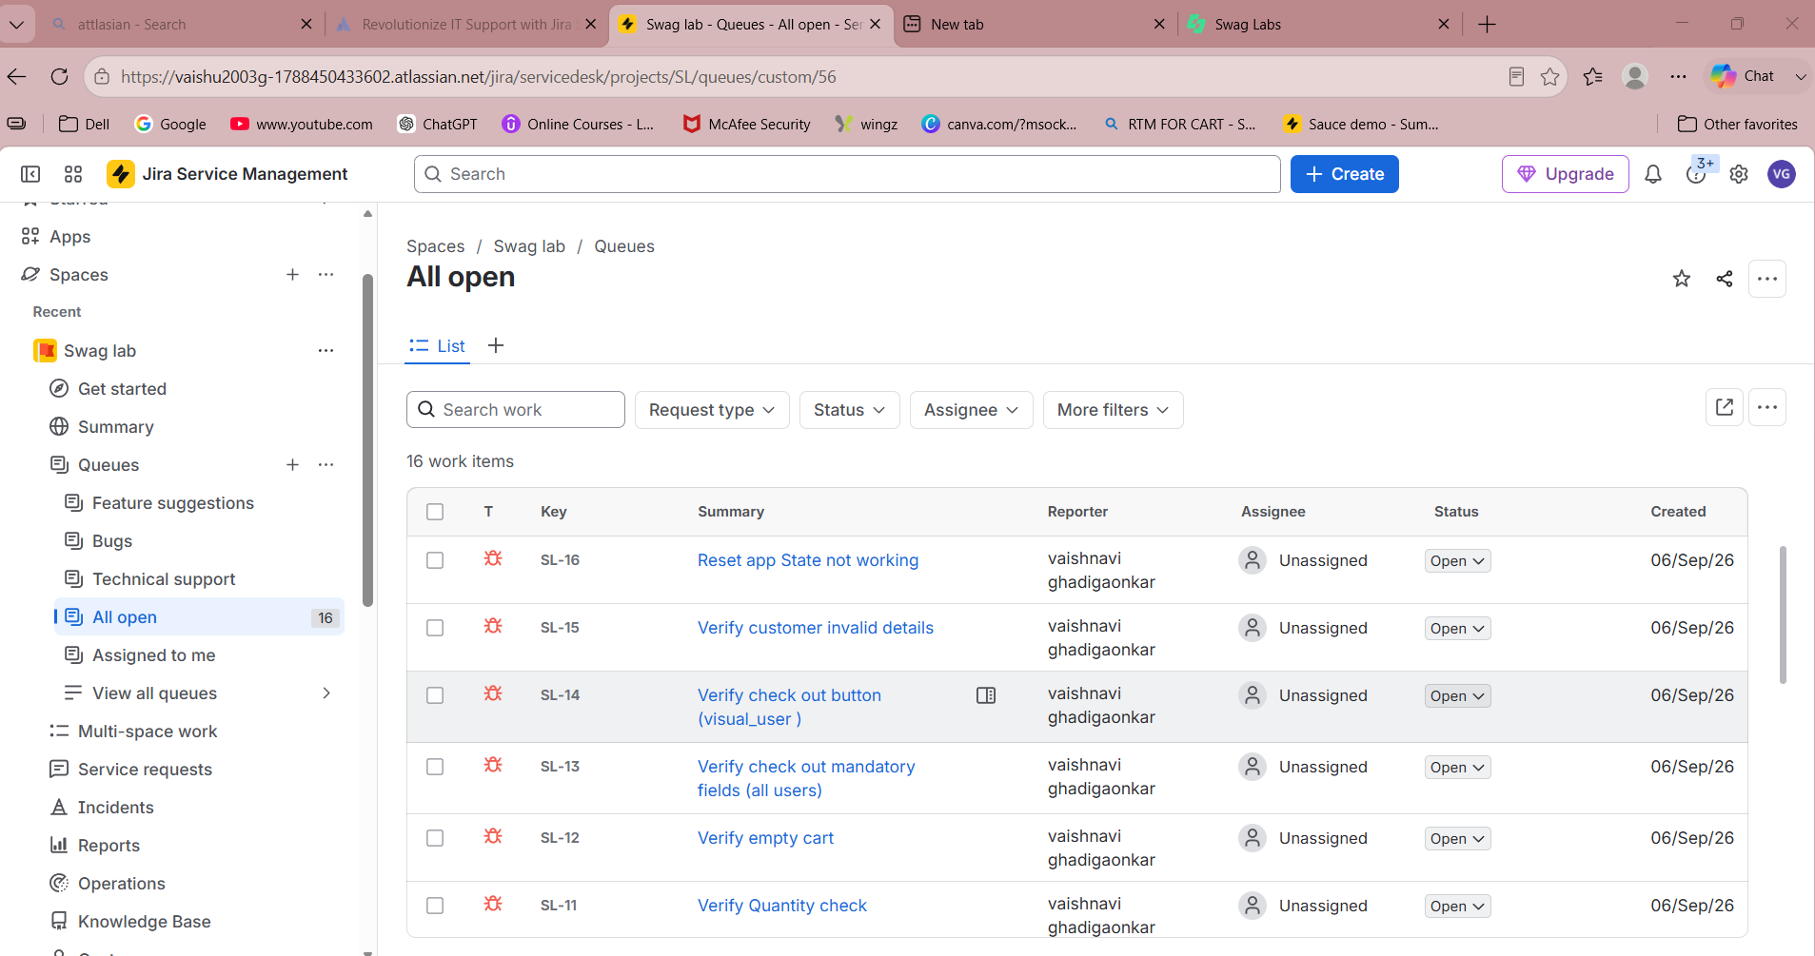

Link: [SL-7] Verify product sorting filteration (visual_user) - Jira
